23 feb@AnkitaSadatpure

Frontend Deployment on aws with amplify

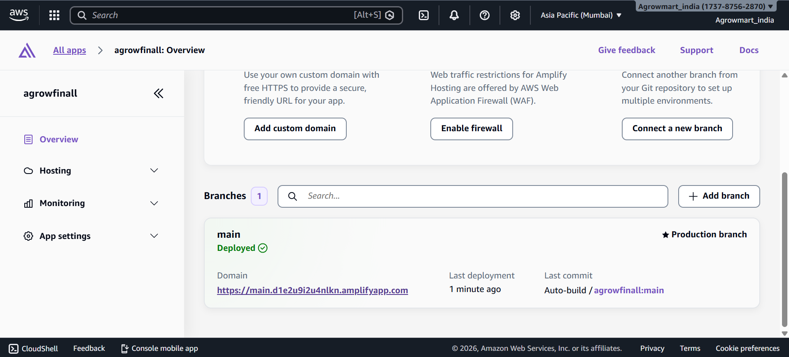

https://main.d1e2u9i2u4nlkn.amplifyapp.com/login

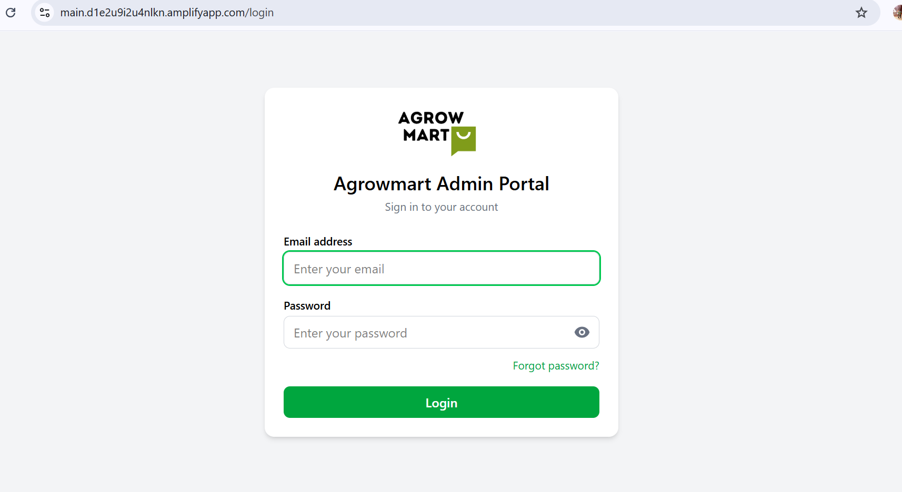

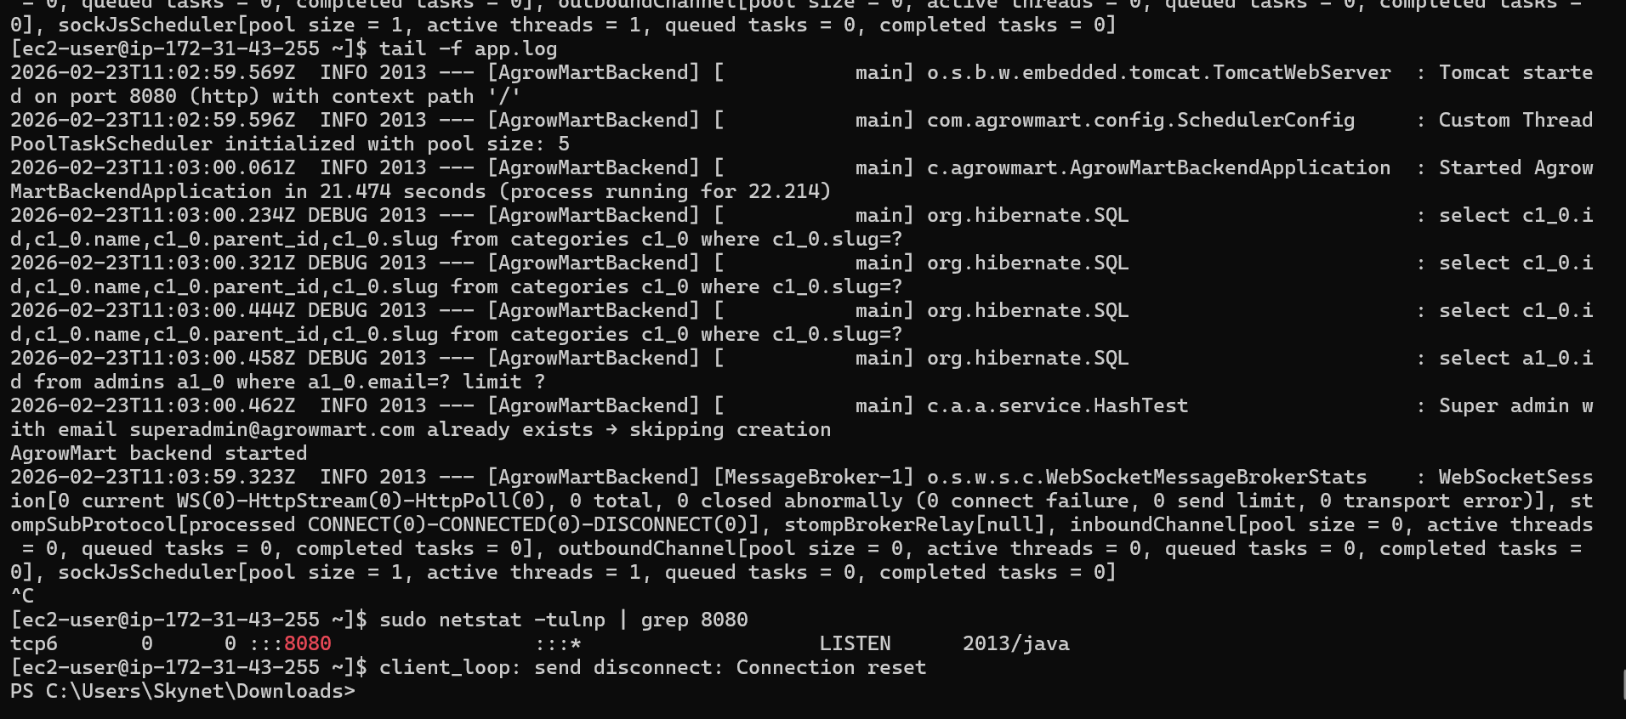

Base Url

http://ec2-13-233-198-153.ap-south-1.compute.amazonaws.com:8080

Base API URL
http://ec2-13-233-198-153.ap-south-1.compute.amazonaws.com:8080/api
Health Check
http://ec2-13-233-198-153.ap-south-1.compute.amazonaws.com:8080/api/health
Root Test
http://ec2-13-233-198-153.ap-south-1.compute.amazonaws.com:8080

